**ASSIGNMENT 5.3**

PROBLEM STATEMENT:

**1)** **Implement the use case present in below blog link and share the complete steps along with screenshot(s) from your end.**

**Link:** <https://acadgild.com/blog/pig-use-case-pokemon-data-analysis/>

Solutions:

Load_data = LOAD ‘/home/acadgild/pig/Pokémon.csv’ USING PigStorage(‘,’)AS(Sno:int,Name:chararray,Type1:chararray,Type2:chararray,Total:int,HP:int,Attack:int,Defense:int,SpAtk:int,SpDef:int,Speed:int);

1) Find the list of players that have been selected in the qualifying round (DEFENCE>55).

Query:

selected_list = FILTER Load_data BY Defense>55;

Output:

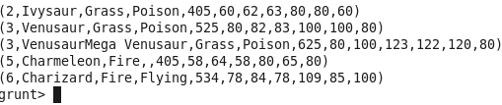

2) State the number of players taking part in the competition after getting selected in the qualifying round.

Query:

group_selected_list = Group selected_list All;

count_selected_list = foreach gourp_selected_list GENERATE COUNT(selected_list);

Output:



3) Using random() generate random numbers for each Pokémon on the selected list.

Query:

random_include1 = foreach selected_list GENERATE RANDOM(),Name,Type1,Type2,Total,HP,Attack,Defense,SpAtk,SpDef,Speed;

Output:

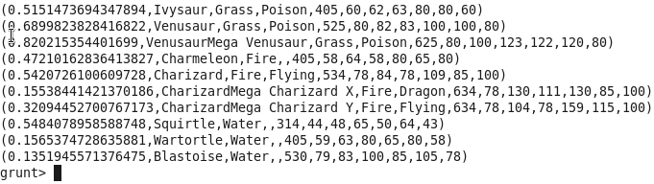

4) Arrange the new list in a descending order according to a column randomly.

Query:

random1_descending = ORDER random_include1 BY $0 DESC;

Output:

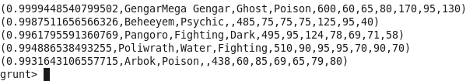

5) Now on a new relation again associate random numbers for each Pokémon and arrange in descending order according to column random.

Query:

random_include2 = foreach selected_list GENERATE RANDOM(),Name,Type1,Type2,Total,HP,Attack,Defense,SpAtk,SpDef,Speed;

random2_descending = ORDER random_include2 BY $0 DESC;

Output:

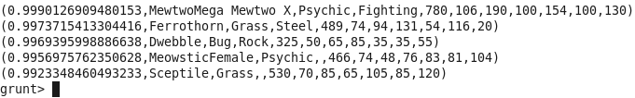

6) From the two different descending lists of random Pokémons, select the top 5 Pokémons for 2 different players.

Query:

Player1

limit_data_random1_descending = LIMIT random1_desending 5 ;

Player2

limit_data_random2_descending = LIMIT random2_desending 5 ;

Output:

Player1

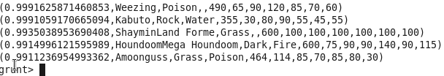

Player2

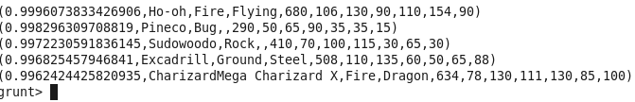

7) Store the data on a local drive to announce for the final match. By the name player1 and player2 (only show the NAME and HP).

Query:

Player1:

filter_only_name1 = foreach limit_data_random1_descending Generate ($1,HP);

Player2:

filter_only_name2 = foreach limit_data_random2_desending Generate ($1,HP);

**For storing the files in local mode.**

Player1

STORE limit_data_random1_descending INTO ‘/home/acadgild/pig/player1.txt’;

Player2

STORE limit_data_random2_descending INTO ‘/home/acadgild/pig/player2.txt’;

Output:

Player1

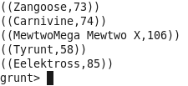

Player2

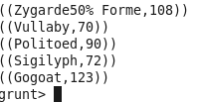

Storing the files in local mode

Player1

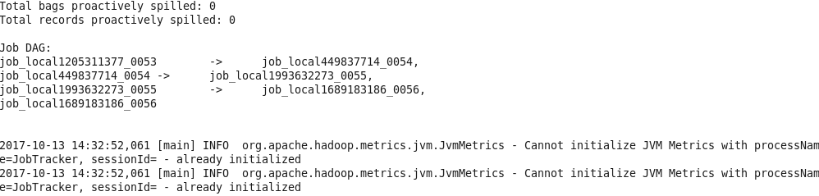

Player2

